June 2023
The last quarter sees our youth work provision transition through the spring term and into the summer term, bringing change to Waterside Centre as well as to the local community.
March is a month of bringing the second term of schools work to a close; by this point in the year our individual relationships with schools and staff are well-established and ensure that we can make the most of the mentoring programme. In April we have the Easter programme, which brings many new faces to Waterside for activities and workshops. The month of May was another busy one, with various community celebrations and events, as well as our half term workshops.
We said thank you to our youth worker Keli-Jo, who is leaving us to pursue her travelling dreams. The team will miss her presence in the programmes, but look forward to seeing her later in the year as she will continue to work with us in a sessional capacity – she just couldn’t say goodbye to Berkshire Youth completely!
From March to the end of May 2023, we have had 1,289 attendances through Waterside programmes and activities, whilst also accommodating an estimated 4,319 attendances through our room hire opportunities.

Activities
- In-School Mentoring Project – as youth workers, one of the main parts of our job is to provide mentoring in all of the secondary schools across West Berkshire. By working 1:1 with young people, we are able to build relationships with them during times of challenge, particularly when they are finding school difficult to engage in. We become a positive presence in their week and aim to help young people set achievable and meaningful goals towards improving their experience of school as a whole. With bank holidays and school strikes bringing changes to multiple weeks of normal schooling, our commitment and consistency has been key to providing young people with a point of contact over the last few months. Since September, we have had 140 individuals referred into the mentoring project.

- Detached Work – our detached programme continues each month as the team build relationships with young people in and around the community. Young people learn to recognise the team and this then further improves and encourages interactions with us both at Waterside Centre and when working in schools. This quarter has seen the return of the Sports in the Park element of our detached programme, where the team set up sports activities in particular parks for open-access participation by young people. Ken is now offering these sessions on a weekly basis at Victoria Park. The sessions are a great way to engage young people who may not normally interact with us, whilst also offering opportunity for them to practise skills and meet new people with the support of a youth worker.

- Youth Club Paddling – the month of April brings paddling back to Waterside Centre and, whilst the weather that month was not always the most reliable, our young people’s enthusiasm for the activity didn’t falter. Youth Club Paddling sessions take place weekly on a term time basis, as well as play a big part in our Easter and half term programmes.
We have also been able to re-introduce Schools Paddling to young people from the Personalised Learning Unit at St Barts.
Overall paddling activities, including school sessions, has seen 167 attendances since April 2023.

- Waterside Junior Paddle Club (British Canoeing) – as registered British Canoeing coaches, David and Kelly have started doing paddle sessions with young people who are looking to take paddling to a more developmental stage (such as racing or instructing skills). Over the first two sessions that have taken place this summer term, there have been 13 attendances.

- Youth Club Climbing – climbing sessions continue to take place at Waterside. The sessions and activity are a good draw in for first time participants who have never accessed Waterside Centre before. Feedback from climbing sessions has shown that young people appreciate the exercise it brings and that they choose to attend because they “get a break from my exams”.
This term we’ve been successful in securing funding for further equipment needed to support more inclusive and accessible climbing options, and our Young Leaders have submitted a video for further funding explaining why extra equipment and a reset of wall runs means that the activity sessions would become better for all young people. Local group Swings & Smiles are supporting our request for funding for this and will be looking to do sessions with us in the future terms as we install the new equipment.
Overall, March – May sessions have had 104 attendances at climbing sessions.

- Young Leaders – from helping out in the various programmes each night of the week and running the Wooden Spoon Café (youth-led coffee bar), to supporting community events and being friendly faces to our visitors, our Young Leaders continue to lead the way in all that we do. Credit goes to them for running activities for the public as part of our Community Coronation Celebration event, where they hosted sports, arts and crafts and face painting. In March, the final two Waterside Series events took place at Waterside Centre. These paddling races are co-ordinated by our friends at Newbury Canoe Club and over 300 paddlers participate in the four-part series. With two events in February and two events in March, it was important for us to have the commitment from the Young Leaders in facilitating the days by hosting the service of food and drinks to all of the racers.
A huge shout-out also needs to go to Eloise and Willem who chose to run the Newbury 10K event as Young Leaders, and subsequently raised over £350 pounds for the Waterside Centre youth programme.

- Youth Café – Tuesday nights are Youth Café nights for the Waterside youth programme. Sport in Mind continue to provide coaches at the term-time sessions and young people enjoy the variety of activities on offer to them each week. The most recent addition to the Youth Café is the pool table, which immediately become a favourite element of the sessions for our young people. Whilst they enjoy challenging Kelly and Ken’s pool skills at every opportunity, the young people have also taken it upon themselves to teach each other how to play. This has made the pool table a natural way to facilitate the young people’s social learning.

Our young people completing their volunteering aspect of their Duke of Edinburgh (DofE) award have continued to support the set up and running of the Youth Café sessions too. Since March, the Youth Café sessions have had 178 attendances.

- Women & Girls Boxing – our youth worker Jessica has seen the development of these sessions with local women of all ages. Every Wednesday, Thames Valley ABC provide a coach to offer the fitness-based sessions that encourage women to connect and enjoy the sport together. Over the months of March, April and May, there have been 106 attendances at these sessions.

- Zen of Happiness – these youth yoga, mindfulness and breathing techniques sessions have a regular cohort of young people who attend on a weekly basis. Instructor Veronika has also announced plans for a Teen Wellbeing Day in August as an extension of the Zen of Happiness partnership and we are excited to be supporting the event and hosting it at Waterside Centre. Since March, there have been 47 attendances at Zen of Happiness sessions.

- Holiday Programmes; Easter and May Half Term – our holiday programmes always bring new young people into Waterside, as regular attendees bring along friends and family to celebrate the end of school terms and look for something different to do in their free time.
The Easter programme accommodated Kids Club (primary school age group) and Youth Club (secondary school age group) programmes with a range of activities on offer to participants, as well as individual workshop sessions for a range of ages. Activities included paddling, climbing, sports and games, arts and crafts and team challenges.
We were also lucky enough to have visits from the Reptile Man, who brought along his friends; snake and lizard to meet our children and young people. It was a great way for participants (and staff!) to face a fear by holding, touching, or even just being in the same room as an animal that they may not have seen before. The café team even came along to join us in these sessions to say hello too, which was a great way for our young people to engage further with the team who provide the food element of the Holiday, Activity and Food programme, funding that supports the delivery of the Easter programme. Over the course of the two weeks of the Easter holidays, we had 357 attendances at workshops, Kids Club and Youth Club.

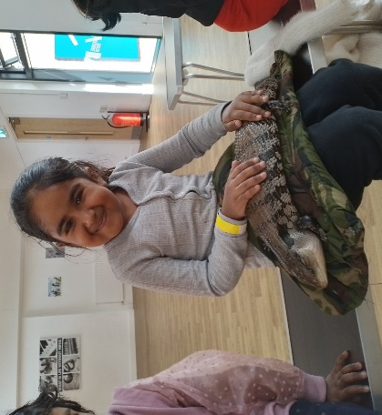

May Half Term activities had 40 attendances, focused on delivering climbing and paddling sessions. In addition to this, we also hosted a trip to Cloud 9 Pursuits’ Wokingham Waterside Centre where 11 young people participated in a four-hour paddle training day with the team.

- Community Outreach and Engagement
  - Community Coronation Celebration – Kerrie developed a day of activities to be offered to the community by inviting partners to get involved. Swings & Smiles hosted a sensory room, MNR Coaching provided multi-sports for the primary school age group, Pageants provide the balloons and decorations, whilst our Young Leaders led the sports for secondary age group, arts and crafts, photobooth and face painting. A visit from the Mayor of Newbury also surprised young people, who then proceeded to join the game of football taking place in the Treacher Hall.

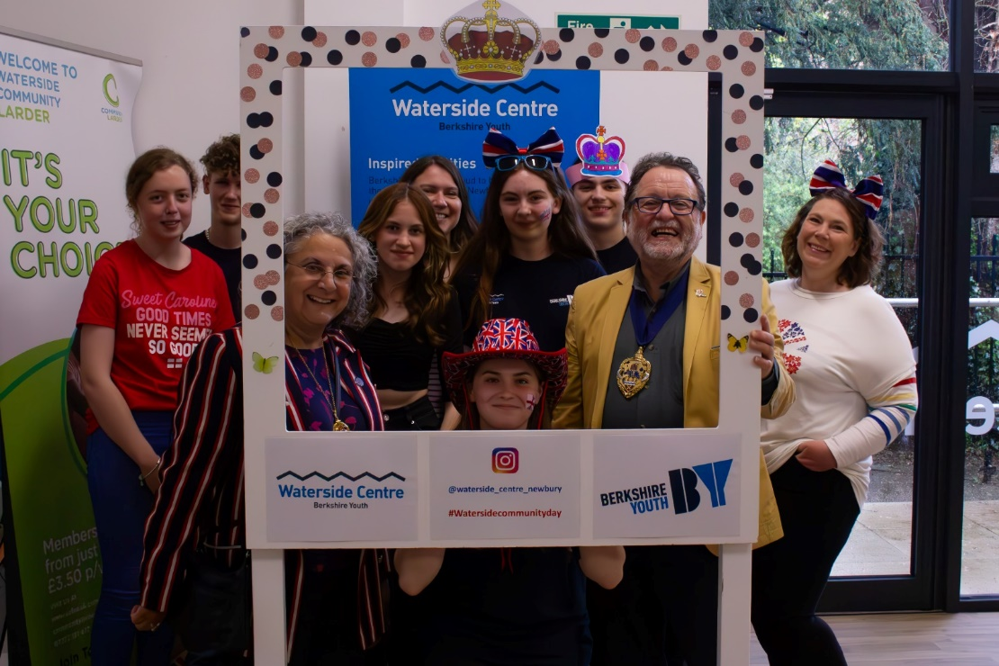

  - Brightwalton Youth Club – Kerrie has been delighted to support the opening of this youth club, in partnership with Brightwalton Parish Council, in recent months, and it has been fantastic to see so much support in the local community for those leading this development.

  - Microfocus Earth Day – on Earth Day in April, a group of volunteers from the Newbury-based company Microfocus came along to Waterside Centre for the afternoon to make seed-bombs for another charitable cause, as well as to fill and make some new planters for the Waterside courtyard space. The environmental focus of the group has brought colour and character to the outdoor space which in the summer season is very popular with our café visitors and young people.

  - Newbury 10K – brought back by Newbury Athletic Club for the first time since Covid-19, the event took place around Newbury with Berkshire Youth being recognised as the nominated charity of the event. Young Leaders, staff and partners ran on behalf off Berkshire Youth alongside almost 1,000 participants on the day.

  - Champions of Youth Work Conference – Berkshire Youth’s annual youth conference took place at Waterside Centre in May, bringing together youth work representatives, professionals and organisations from across the county. Leigh Middleton, CEO of the National Youth Agency was the keynote speaker. Pledges for youth work visions for 2023 were also announced by attendees.

  - Theale Parish Council – youth worker Ken and Kelly joined Berkshire Youth Ambassador Tom Holmes in attending the opening of new park facilities and MUGA in Theale. Young people took part in basketball and football, whilst residents discussed the thrill of having new equipment installed in the park. At the end of the afternoon, Tom kindly arranged to sign autographs and take photos with the community.

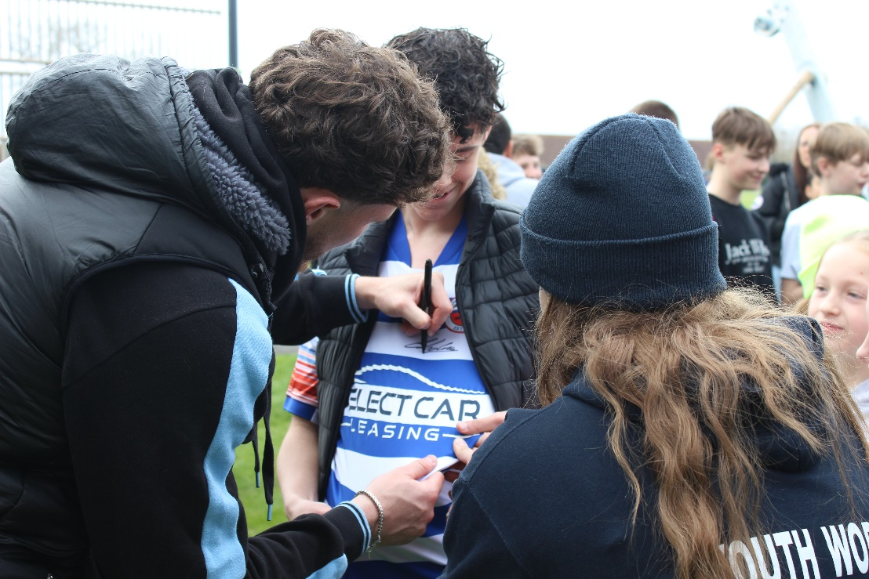

  - Trauma-Informed Training – as a relevant topic for those who work with young people and the community, we were proud to host this training event and offer the opportunity for professionals to access specialist discussions and training in the area.

Partnerships
- Cloud 9 Pursuits – the instructors from Cloud 9 continue to support all that we do in the way of climbing and paddling sessions. They build positive relationships with our young people in order to instil confidence and inspire them in their participation at those youth club sessions. By hosting activities at their own centre in Wokingham, we were able to offer a slightly different opportunity for young people to access and develop their paddling skills. In the summer term, they will also help us to host a county-wide paddle activity day for our youth club network.

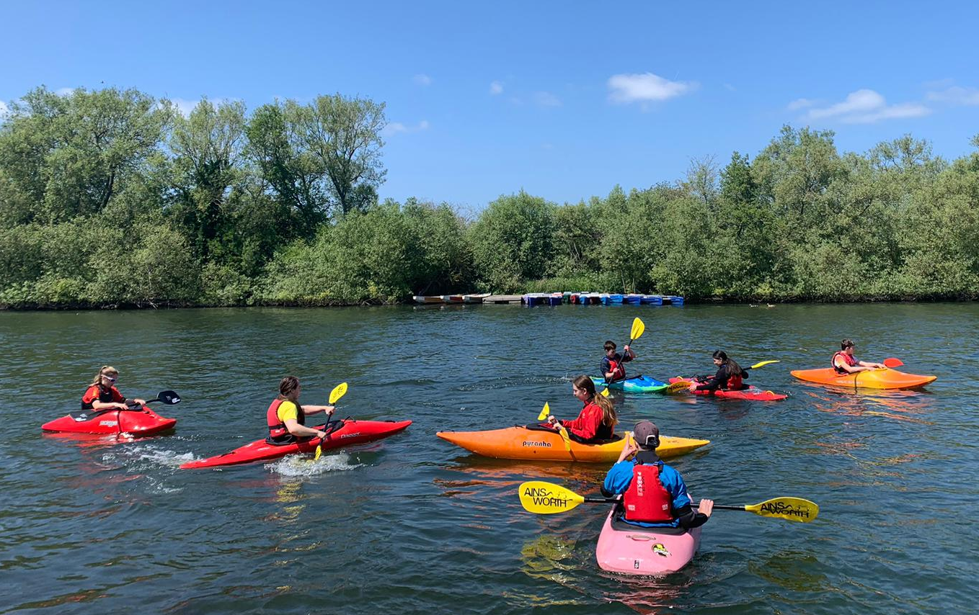

- Thames Valley ABC – this quarter has brought the TVABC Open Show to Waterside Centre, where clubs from across the country link up with Thames Valley ABC to bring amateur boxers together in club competition. Young Leaders from our BoxWise programme hosted the Wooden Spoon Café, serving hot drinks and snacks to competitors and attendees.

- BoxWise – this programme is seeing an increase in interest and has sparked further conversation about more opportunities for non-competitive-related sports programmes in the community. BoxWise London send us their fantastic coach Nick every week, who works alongside our youth workers to create a space for young people to learn new skills, improve fitness and communication, and overall engage in a community programme. Two of our young people who have attended BoxWise regularly have now become Young Leaders and support other young people to make the most of the sessions. One of them has also transitioned into training weekly with Thames Valley ABC. In the March – May sessions, there have been 88 attendances at BoxWise sessions.

- SOFEA / FareShare – Waterside Community Larder – SOFEA donates surplus food sourced through the FareShare network into the Community Larder for our members to access for a nominal membership. Our number of memberships to the Community Larder has increased to 48 active memberships, and the addition of Marks & Spencer produce in the regular stock supplied by SOFEA has increased the variety on offer each week.

- Wooden Spoon Café / Colline’s Kitchen – our café space is enjoying the brighter weather and making the most of the beautiful scenery accessible via the courtyard. Half term and holiday programmes mean that parents often stay to enjoy tea, coffee, snacks and cake from the café whilst also being able to see their children and young people enjoy our activity offer.

- Tilehurst Parish Council – with brighter nights setting in over the spring term, the Calcot Youth Club sessions were able to move parts of their sessions outside. Jessica and the team have encouraged the young people to be outdoors and the young people have enjoyed the opportunity to play different sports. Using the patio and grassy spaces around the centre also means that messy challenges and games. There have been 178 attendance since March 2023.

- Educafé and Nourish by V continue to support the development and delivery of our Zen of Happiness sessions and, as mentioned above, will continue to work with us over the summer holiday period to provide a Wellbeing Festival and workshops in our Youth Club programme.

- The Music Lounge – Berkshire Maestros have been busy getting ready for the next Youth Music Night which takes place in June.

Centre Bookings
- VoxFresh – Friday evenings wouldn’t be the same without the voices of VoxFresh’s young people filling Waterside Centre. Our ongoing partnership with Kat also leads to opportunities with the charity VoxThrive which supported our Easter Youth Club programme by providing a song-writing workshop, led by their older young people.

- Westies – West Berkshire Dance Company, better known as Westies, continue to facilitate their Friday evening classes for young people by hiring out the Kersey Hall every week during term-time. These lovely young people are familiar with the youth worker team and often say “hi” to us when they see us in schools during the week as well.

- Refugee Support Group – a weekly booking in the Avon Room where local families and individuals can access support and signposting opportunities.

- Boogies Mites – as a family favourite, Lizzie is a wonderful weekly booking in the centre. She brings music, laughter and all-round fun to toddlers and their parents every Tuesday.

- Renartgades – this modern-makers fair takes place once a month on a Saturday with an average of 25 stalls offering their craft products and merchandise for sale to the community. April’s fair also hosted two stalls by St Barts students undergoing their Young Enterprise course. The young people had designed T-shirts and bags as part of their course to learn about starting and managing business enterprises and were selling them on the day.

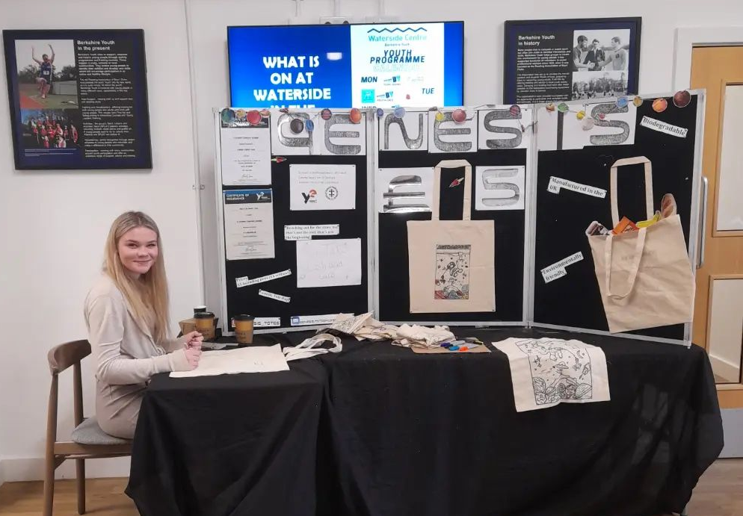

As well as regular bookings, we also have ad-hoc bookings, including:
- Birthday parties and private celebrations – where are rooms are set up according to the different requirements of each individual event dependent on theme, age group and party size.

- Colline’s Kitchen team play host to a weekly Wellbeing Group, who use the Riverview gallery once a week for things like yoga as well as just a space for overall community connection.

- Adult Yoga sessions have also started taking place in the Kennet Studio, again bringing new adults into the building.

- The café space is still popular as a meeting point for family lunches, catch-up coffee and team meetings (with cake!) and this brings a dynamic rhythm to the daily routine of the centre.

Local Media
Team members from Newbury Weekly News have been a great support over recent months, donating time to support us in developing videos for various activities and overall Waterside Centre / Berkshire Youth promotion. They’ve also been keen to highlight our programmes and celebrations. We have just submitted our next article for their Out & About magazine – so keep an eye out for that being available in the local community over the coming weeks!
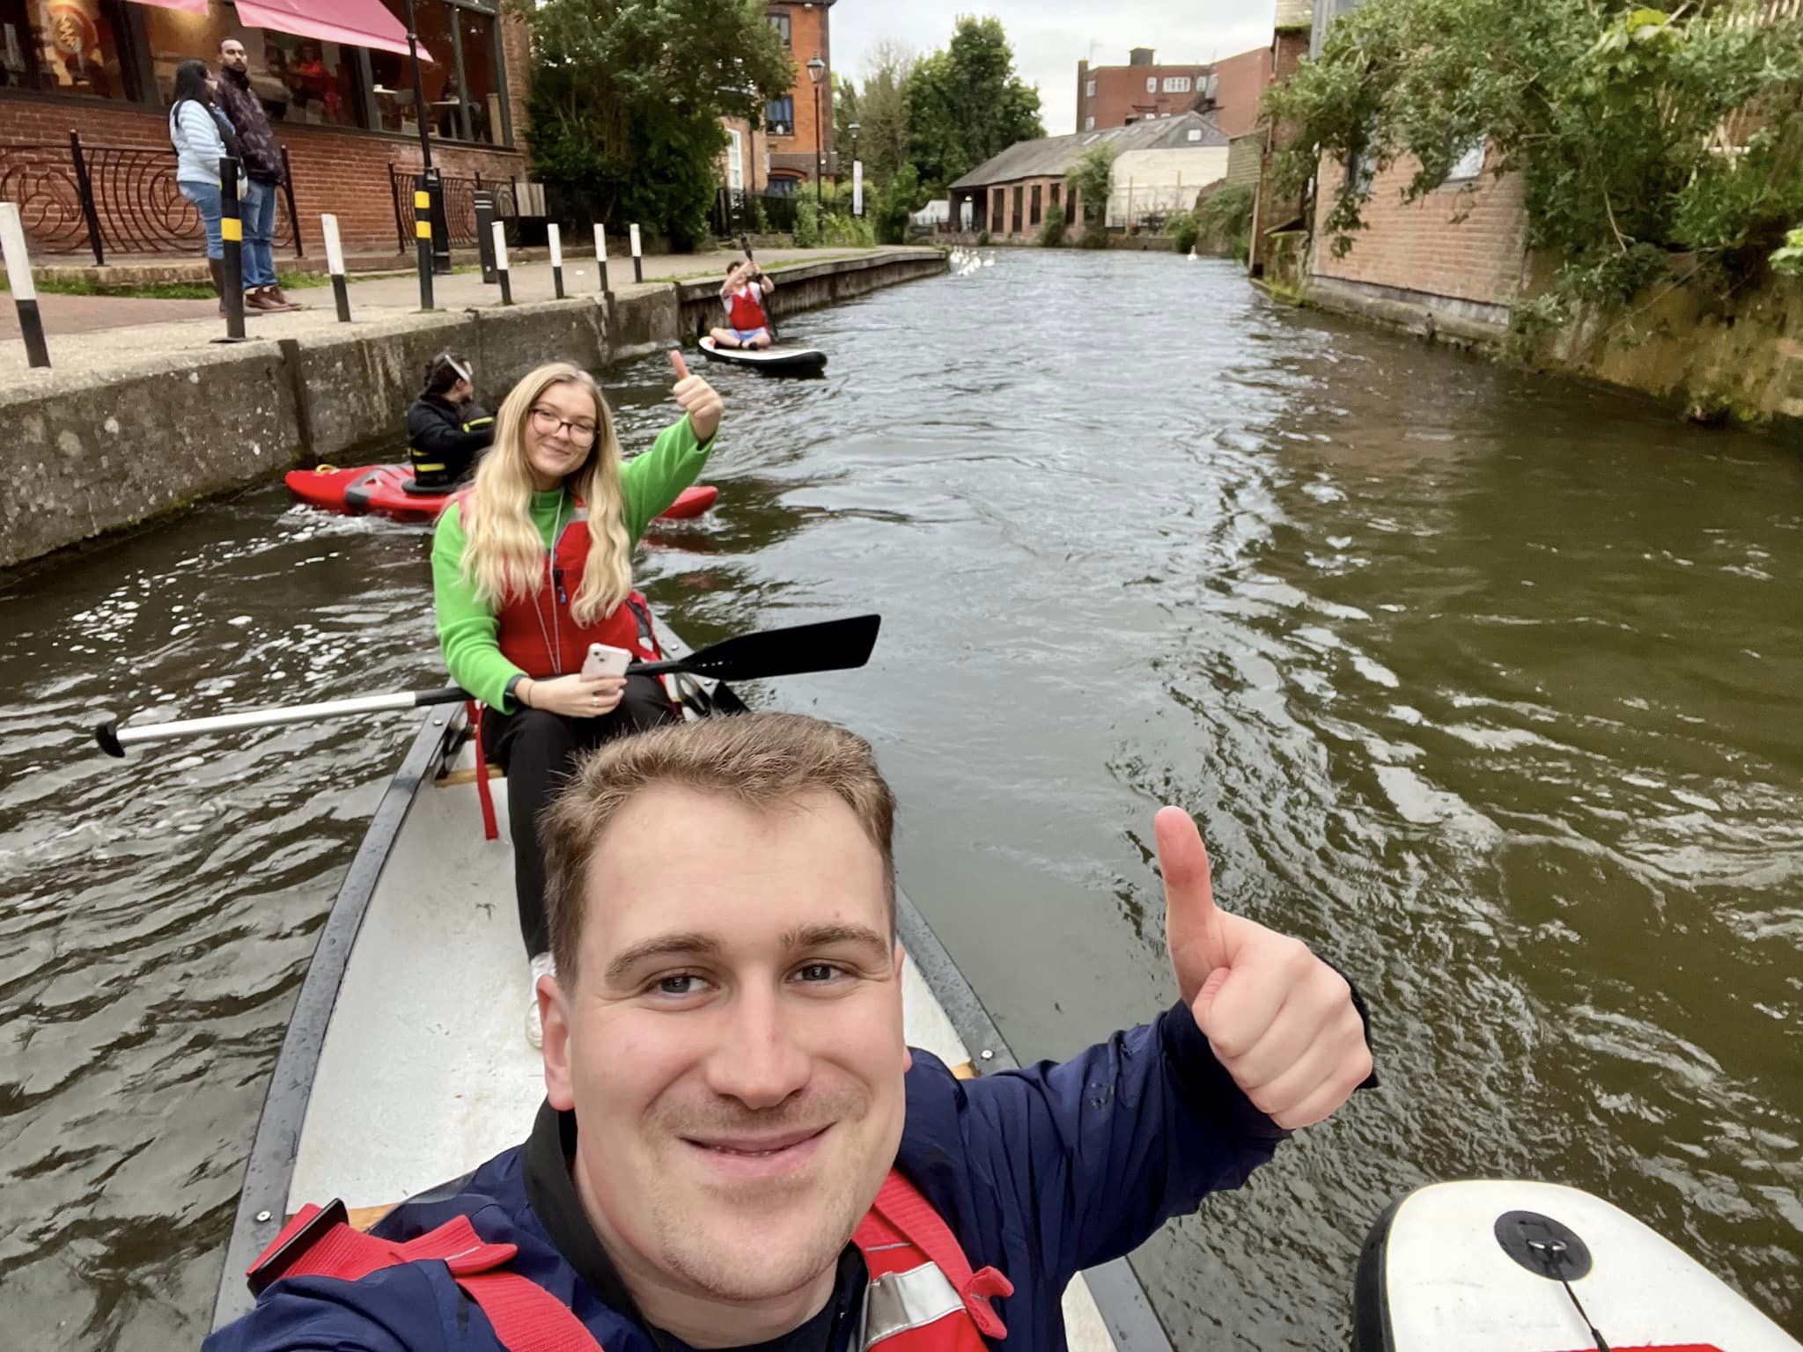

Kennet Radio were a huge support on the day of the Newbury 10K event, where they celebrated Berkshire Youth and encourage participants throughout the day and even let our team mascots (youth workers and young leaders in costumes) talk on the air and thank the attendees.
Young people have also been taking more notice of our social media pages lately and enjoy looking out for photos of the youth workers and their friends in features that we circulate.

Future Plans
Summer – the end of the school term is fast approaching, and one of the team’s favourite times of year is getting underway. This year, the summer holiday programme will be a mix of workshops, Kids Club and Youth Club sessions, with the aim of offering something for everyone across the summer.
Youth Club Boxing – keep an eye out at the start of the autumn term, when we will be integrating a new youth club programme focused on boxing. These sessions will be designed as a mid-point programme to help transition young people from our BoxWise programme into the Thames Valley ABC training sessions.
Wooden Spoon Café – our Young Leaders are currently working on their next fundraising ideas and social action projects, one of which will be a fundraising day where they sell home-made cakes and serve hot drinks to the community by opening their Wooden Spoon Café on a Sunday in the summer.
